**Computational Statistics ||**

**Homework 6**

Subash Kharel

April 23, 2020

1. **Here we explore the maximal margin classifier on a toy data set.**
   1. **We are given n = 7 observations in p = 2 dimensions. For each observation, there is an associated class label.**

|  |  |  |  |
| --- | --- | --- | --- |
| Obs. | X1 | X2 | Y |
| 1 | 3 | 4 | Red |
| 2 | 2 | 2 | Red |
| 3 | 4 | 4 | Red |
| 4 | 1 | 4 | Red |
| 5 | 2 | 1 | Blue |
| 6 | 4 | 3 | Blue |
| 7 | 4 | 1 | Blue |

**Sketch the observations.**  
Answer:

|  |
| --- |
| x1 = c(3, 2, 4, 1, 2, 4, 4)  x2 = c(4, 2, 4, 4, 1, 3, 1)  y = c("red", "red", "red", "red", "blue", "blue", "blue")  plot(x1, x2, col=y) |

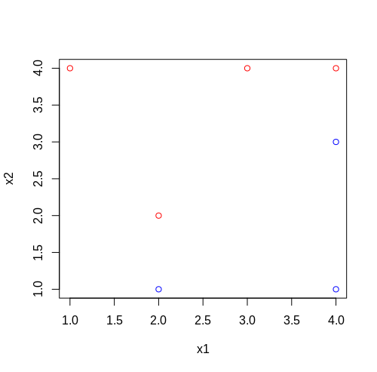

* 1. **Sketch the optimal separating hyperplane and provide the equation for this hyperplane (of the form (9.1)).**  
     Answer: Looking at the graph we can see that the hyperplane is the line that passes through the midway between (2,1) and (2,2), and (4,3) and (4,4). That is, it passes through (2, 1.5) and (4, 3.5). We can derive an equation passing between these lines: y = x – 0.5, which gives intercept = -0.5 and slope = 1. This we can get the line using following command.

|  |
| --- |
| abline(-0.5, 1) |

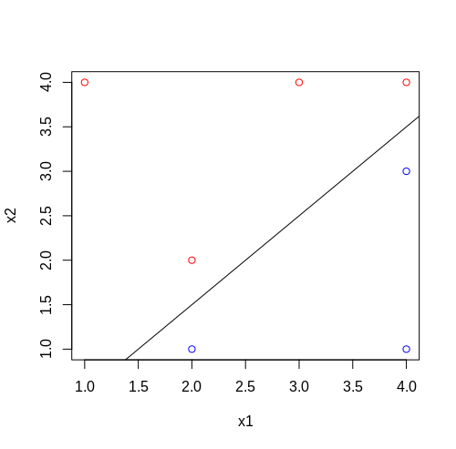

* 1. **Describe the classification rule for the maximal margin classifier. It should be something along the lines of “Classify to Red if β0 + β1X1 + β2X2 > 0 and classify to Blue otherwise.” Provide the values for β0, β1, and β2.**  
     Answer: The classification rule is “Classify to Red if x1 – x2 – 0.5 < 0” and classify “Blue” otherwise. Values for B0 = -0.5, B1 = 1 and B2 = -1.
  2. **On your sketch, indicate the margin for the maximal margin hyperplane.**  
     Answer: The margin for maximal hyperplane is the margin between two sides of the hyperplane. They are two lines passing through (2,1) and (4,3), and (2,2) and (4,4). One of them is y = x – 1 and other is y = x.

|  |
| --- |
| abline(-1, 1, lty = 2)  abline(0, 1, lty = 2) |

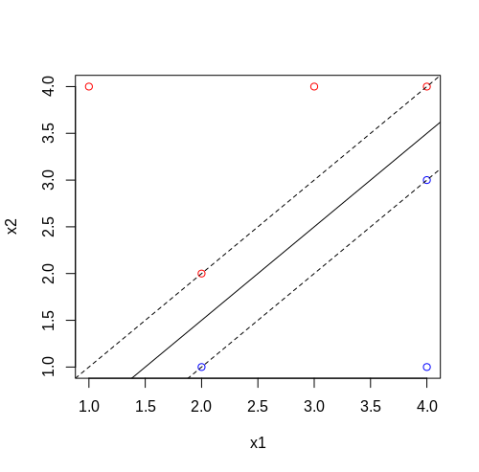

* 1. **Indicate the support vectors for the maximal margin classifier.**  
     Answer: The support vectors for maximal margin classifier are the vectors through points (2,2) and (4,4) and (2,1) and (4,3).
  2. **Argue that a slight movement of the seventh observation would not affect the maximal margin hyperplane.**  
     Answer: As we know that, the maximal margin is affected by the points forming the support vector. As long as the movement of seventh observation doesn’t go beyond the support vector, the maximal margin hyperplane is not affected.
  3. **Sketch a hyperplane that is not the optimal separating hyperplane and provide the equation for this hyperplane.**  
     Answer: We can create any line that resides near to the current support vectors but doesn’t align perfectly with the current hyperplane. It can be something like: y = x – 0.7

|  |
| --- |
| plot(x1, x2, col=y)  abline(-0.7, 1) |

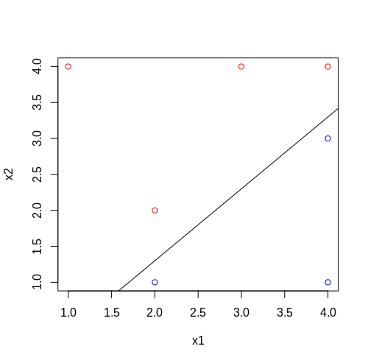

* 1. **Draw an additional observation on the plot so that the two classes are no longer separable by a hyperplane.**  
     Answer: We can add a red point in opposite side of hyperplane where blue points lie or a blue point in opposite side of hyperplane where red points lie.

|  |
| --- |
| x1 = c(x1, 1.5)  x2 = c(x2, 2)  y = c(y, "blue")  plot(x1, x2, col=y) |

